Part 1:

1. Create an abstract class called Shape with pure virtual members called calcPerimeter and calcArea. Create subclasses of Shape called Square and Triangle that inherited the pure virtual members above.
2. Write two non-member functions called printPerimeter and printArea that call the methods calcPerimeter and calcArea respectfully.
3. Instantiate a Square and a Triangle object.
4. Input the radius of a Square and then call the functions printPerimeter and printArea.
5. Input the length of the three sides of a triangle and then call the functions printPerimeter and printArea.
6. Output the perimeter and area of the Square and triangle objects.

Use the following data:

Let 4.66 inches be the length of a side of the Square.

The sides of the triangle are 7.0 feet, 8 feet, and 2 feet

Use Heron’s formula for the triangle

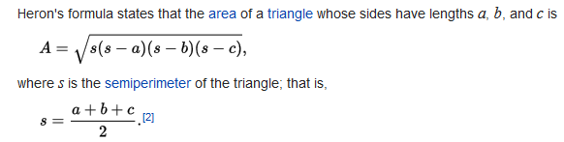

Part 2:

The above program should

* 1. Pass your first and last name as command line parameters
  2. Print your first and last name by using the command line parameters
  3. Print the second character of your first name and last name by using the command line parameters.

Due September 27th